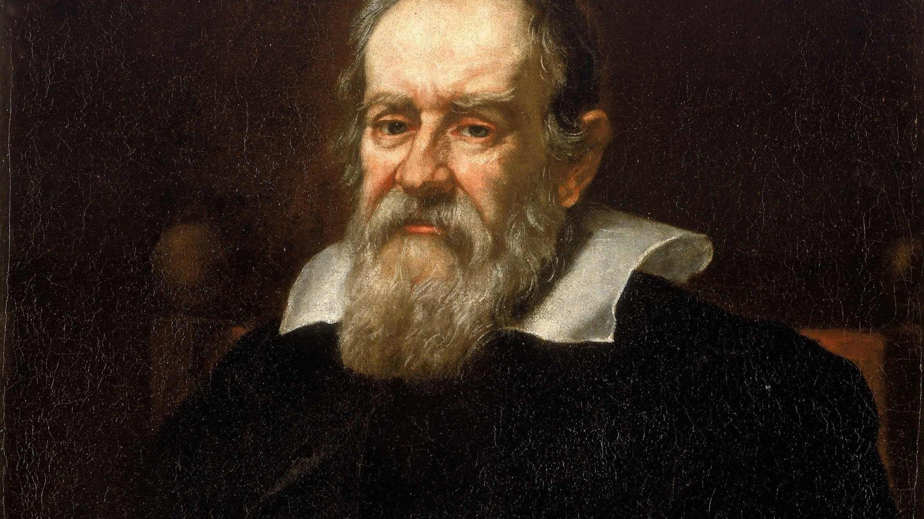***Some Interesting Facts about Galileo***

1. **GALILEO GALILEI PROBABLY NEVER DROPPED ANYTHING OFF THE LEANING TOWER OF PISA**.

With its convenient “tilt,” the [famous tower in Pisa](https://www.mentalfloss.com/article/70395/13-straight-facts-about-leaning-tower-pisa), where Galileo spent the early part of his career, would have been the perfect place to test his theories of motion, and of falling bodies in particular.

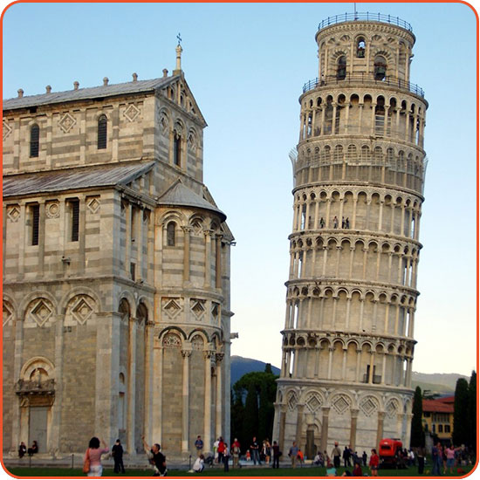

1. **Galileo didn’t like being told what to do.**

As a young professor at the University of Pisa, Galileo had a reputation for rocking the boat. The university’s rules demanded that he wear his formal robes at all times. He refused—he thought it was pretentious and considered the bulky gown a nuisance. So the university docked his pay.

1. **Galileo didn’t invent the telescope**

We’re not sure who did, although a Dutch spectacle-maker named Hans Lipperhey often gets the credit (he applied for a patent in the fall of 1608). Within a year, Galileo Galilei obtained one of these Dutch instruments and quickly improved the design. Soon, he had a telescope that could magnify 20 or even 30 times. As historian of science Owen Gingerich put it, Galileo managed “to turn a popular carnival toy into a scientific instrument.”

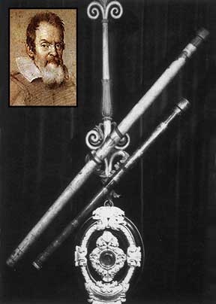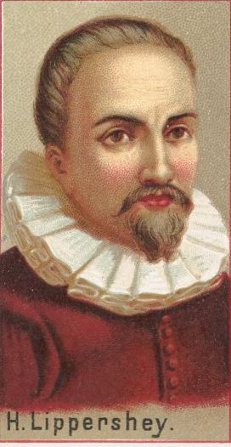

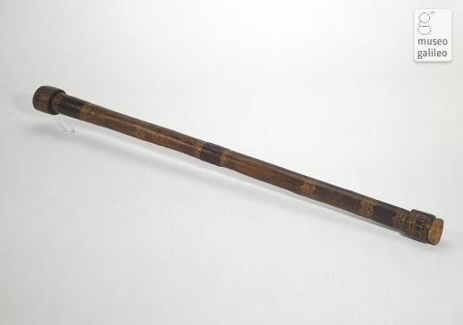

## GALILEO WROTE ABOUT RELATIVITY LONG BEFORE EINSTEIN.

## He didn’t write about exactly the same sort of relativity that Einstein did. But Galileo understood very clearly that motion is relative—that is, that your perception of motion has to do with your own movement as well as that of the object you’re looking at.

## GALILEO HAD SOME BIG-NAME VISITORS WHILE UNDER HOUSE ARREST.

## Charged with “vehement suspicion of heresy,” Galileo spent the final eight years of his life under house arrest in his villa outside of Florence.

## 

## The scientist dropped out of university

## He became blind (but not by the Sun)

## Galileo continued working and writing while imprisoned for heresy in his home near Florence, and during this time, his vision began to blur. By 1638, the astronomer had become completely blind. This condition was probably [caused](https://aty.sdsu.edu/vision/Galileo.html#:~:text=The%20truth%20is%20that%20Galileo,York%2C%20(1999)%3B%20p.) by cataracts and glaucoma.

## 